 **LOVELY PROFESSIONAL UNIVERSITY**

**PROJECT REPORT**

TITLE : TRAVEL WITH US

COURSE CODE : CSE326

GROUP MEMBERS :

Sai Sasank Lakimsetti(12209302)

Rishith Sai Chowdary Chundru(12212330)

Tekulapalli Srihari(12212857)

GRADUATION: Bachelor of Technology

SCHOOL : Computer Science and Engineering

SECTION : K22RP

BATCH : 2022

ROLL NUMBERS : 02,34,42

Submitted to

Dr.Goutam Majumder

Summary:

* This website ‘TRAVEL WITH US’ helps the user to travel all over India by means of transport ‘Trains,Buses,Flights’ and they can book ‘Hotels’ and ‘Meals during Train Journey’.
* The entire website was designed using HTML,CSS.
* In Train services, the user will be able to see submenu as Book Ticket and Cancel Ticket. By clicking Book Ticket, the user will be able to do train reservation and by clicking Cancel Ticket, the user will able to cancel the reserved train ticket.
* In Bus services, the user will be able to see submenu as Book Ticket and Cancel Ticket. By clicking on the Book Ticket, the user can book bus tickets and by clicking Cancel Ticket, the user will be able to cancel the booked bus ticket.
* In Flight services, the user will be able to see submenu as Book Ticket and Cancel Ticket. By clicking Book Ticket, the user will be able to book flight tickets and by clicking Cancel Ticket, the user will be able to cancel the booking.
* In Hotels services,the user will be able to see submenu as Book Accomodation,by clicking on the submenu, the user will be able to book accommodation with our partnered hotels.
* In Meals services,the user will be able to see submenu as Book Meals,by clicking on the submenu, the passenger will be able to order food during their train journey by entering PNR Number with our partnered restaurants.
* The other option which we can able to see was Home. On placing the cursor on Home menu, the user will be able to see submenu as Login and Register. On clicking on Login button,the user will be able to login to his/her account and by clicking on Register, he/she can create a new account.

HOW WE DESIGNED OUR WEBSITE :

HOMEPAGE:

HTML SOURCE:

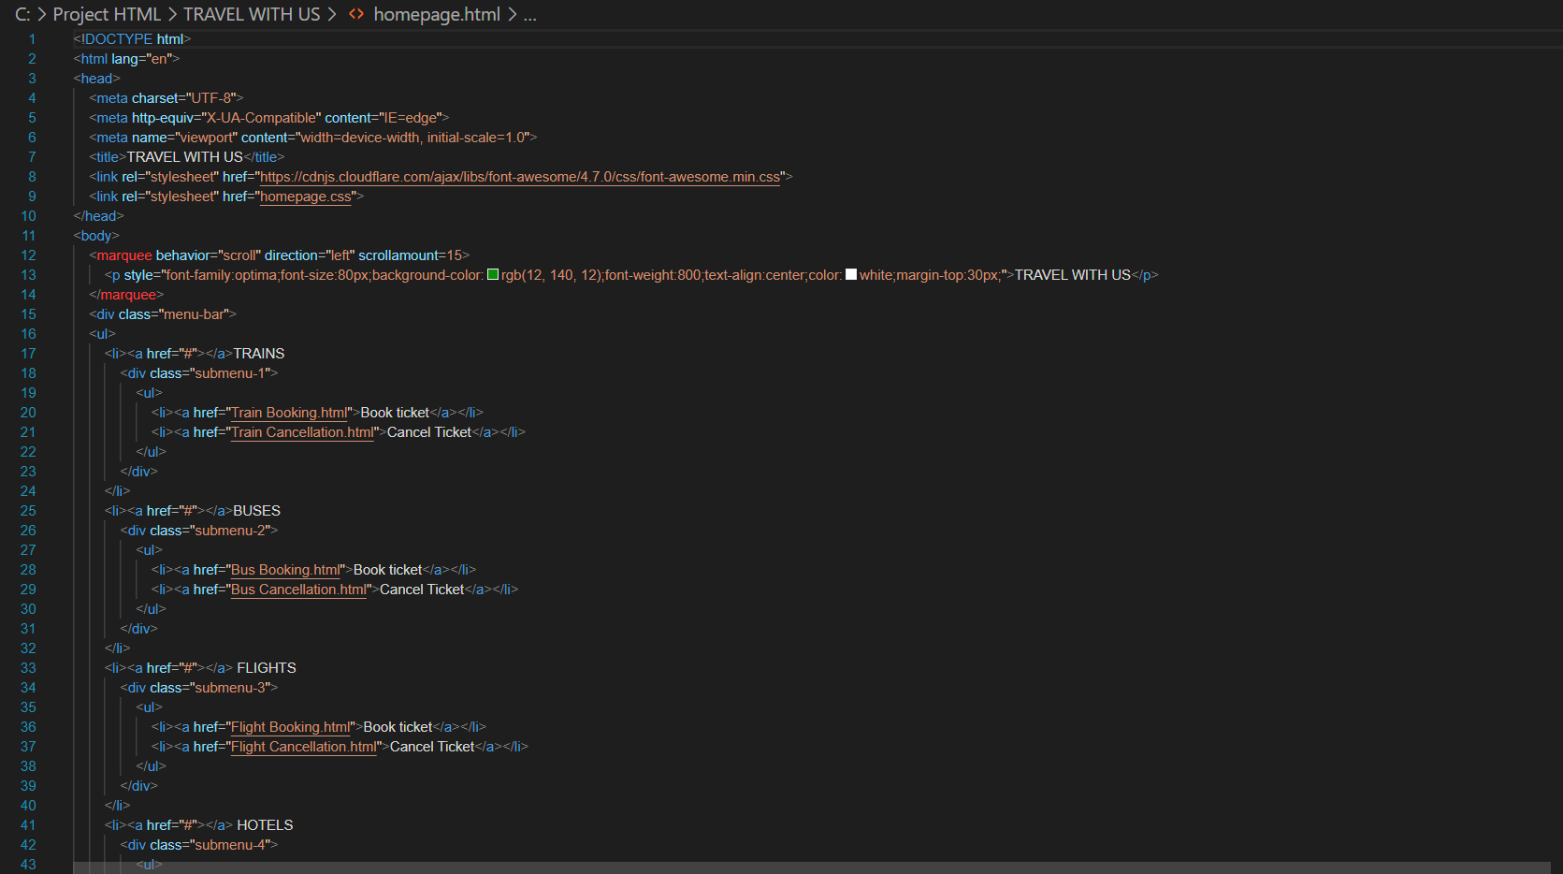

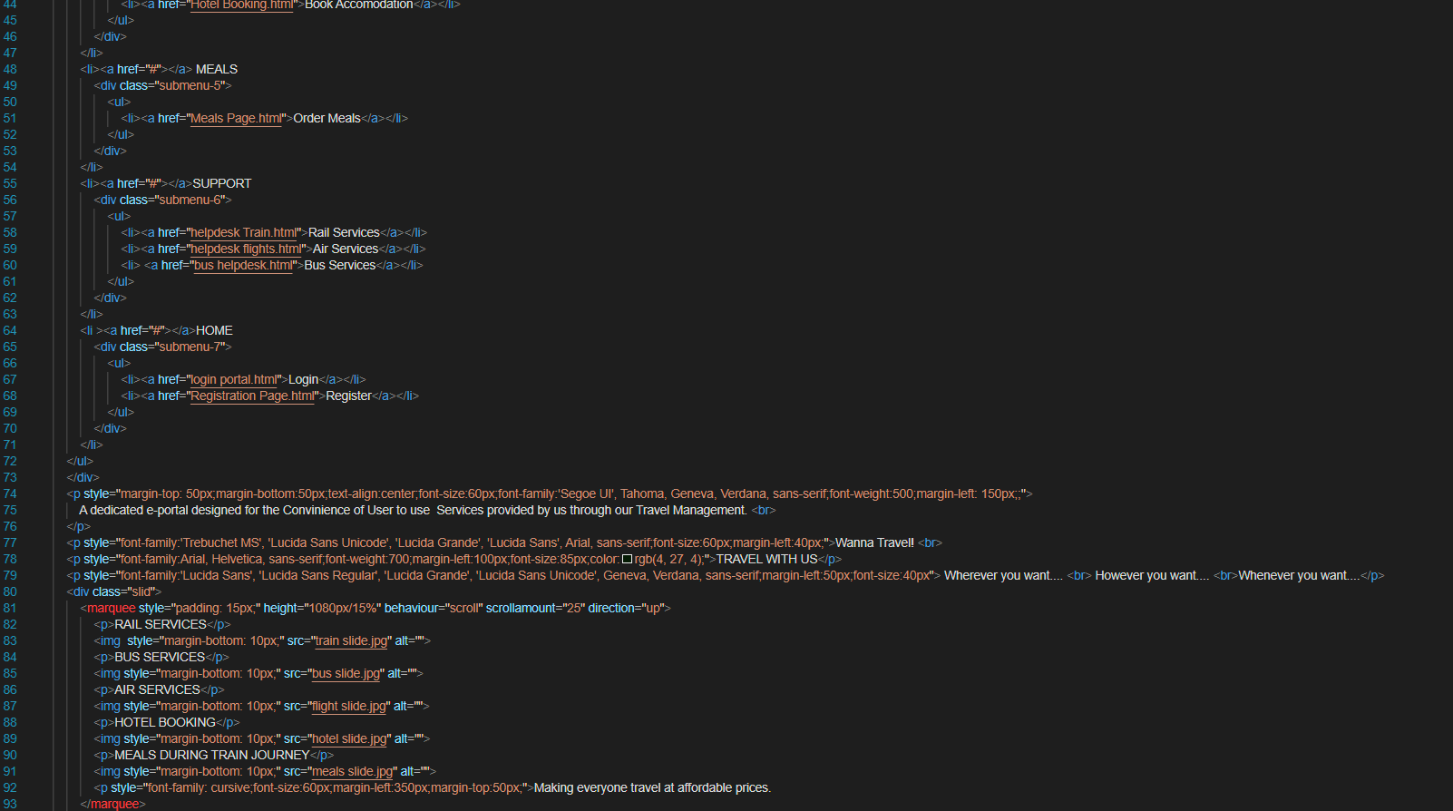

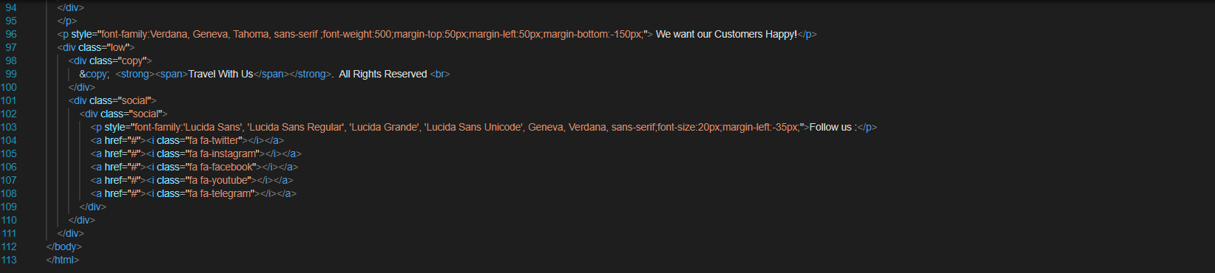

CSS SOURCE:

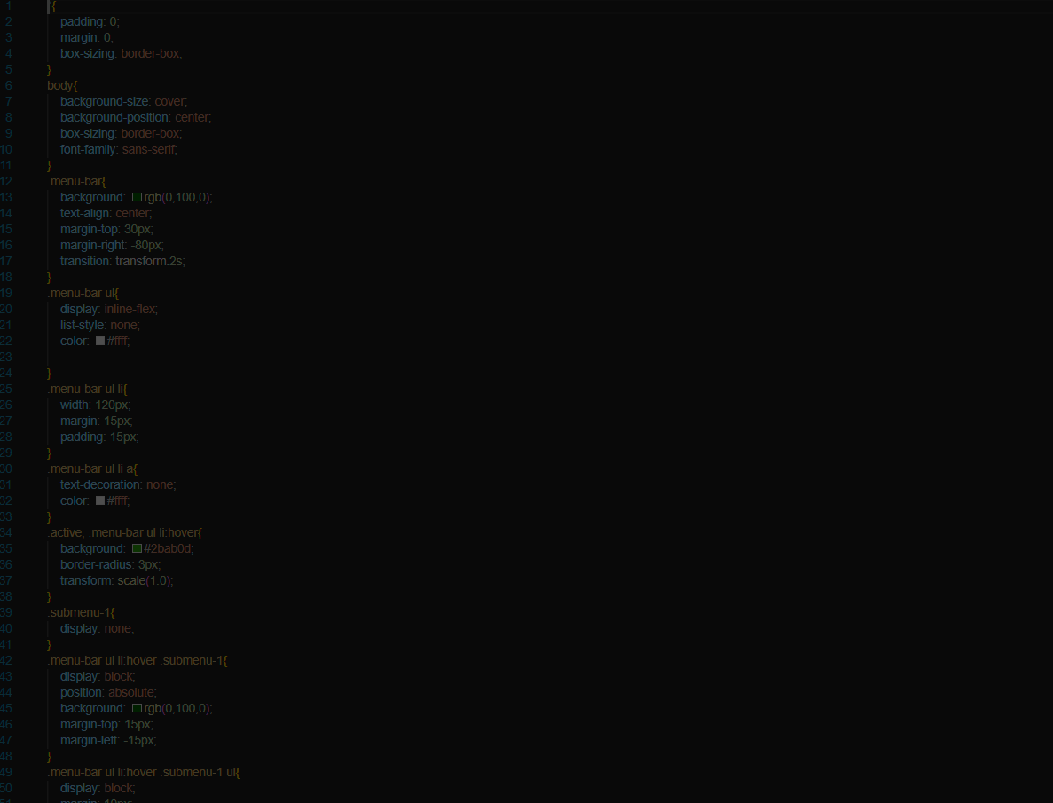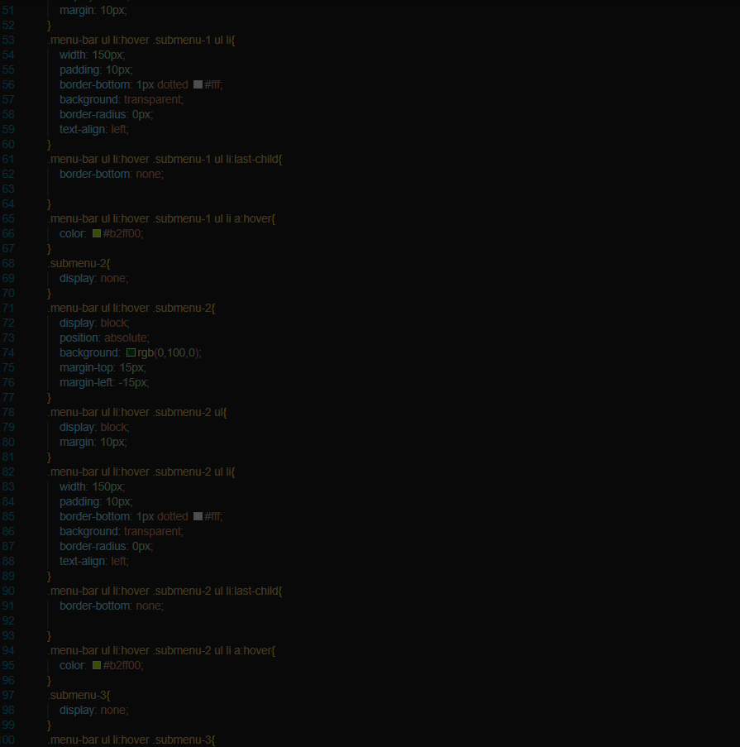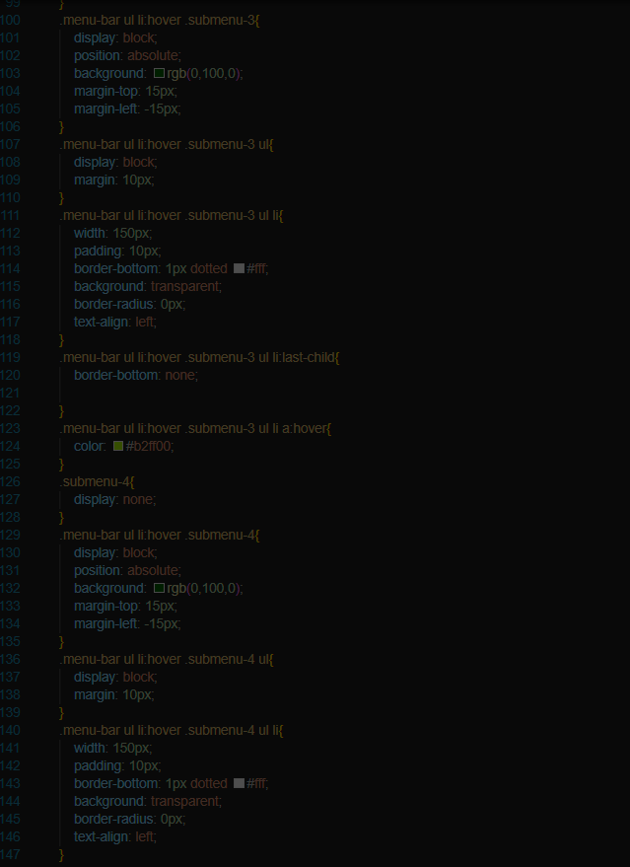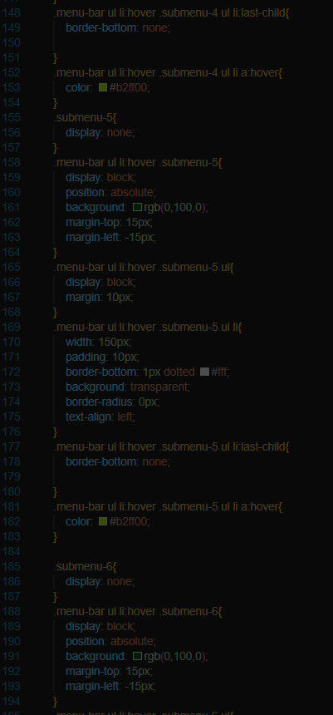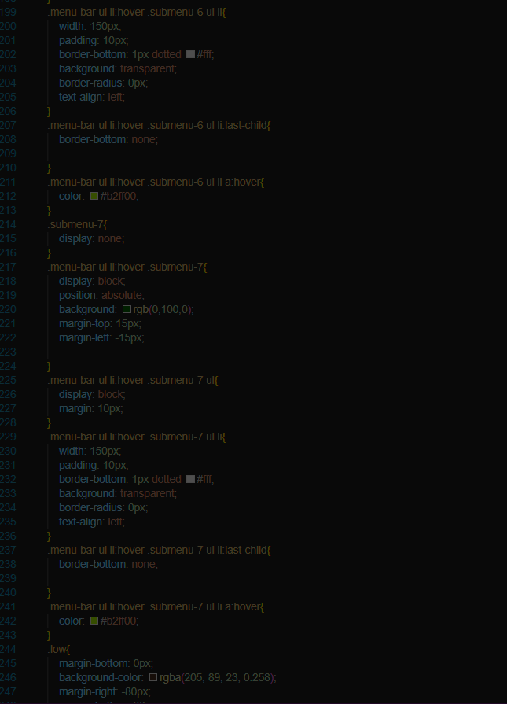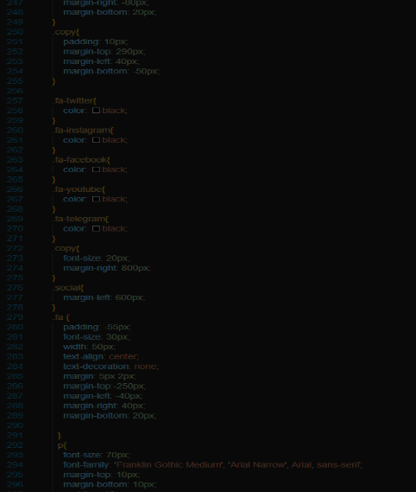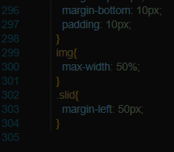

BUS BOOKING:

HTML SOURCE: CSS SOURCE:

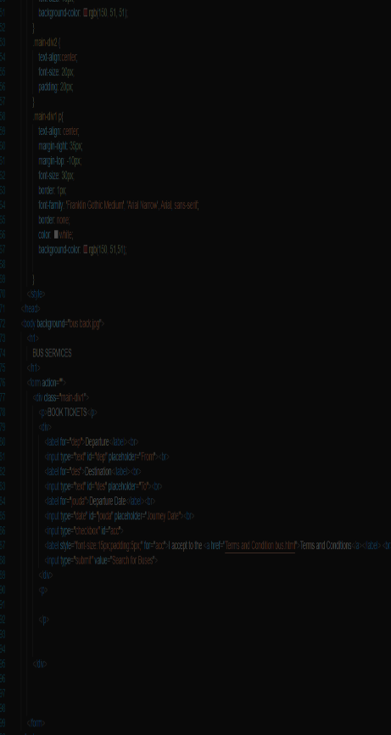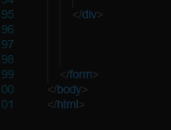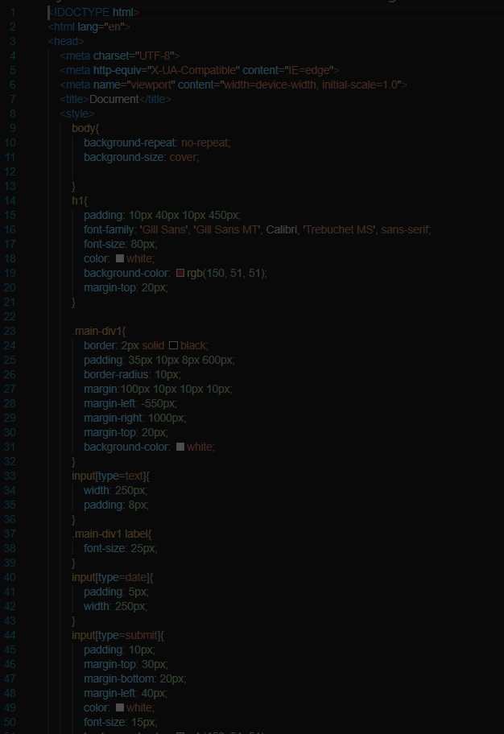

BUS TICKET CANCELLATION:

HTML SOURCE:

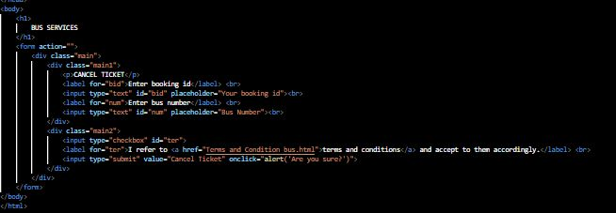

CSS SOURCE:

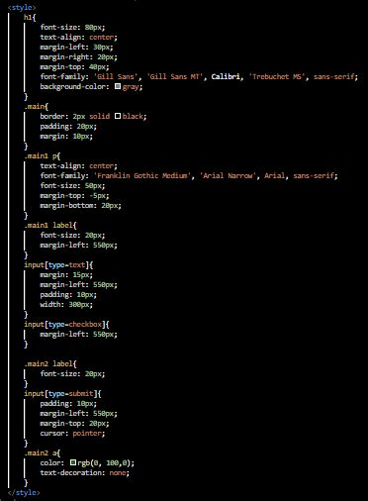

TRAIN BOOKING

HTML SOURCE: CSS SOURCE: 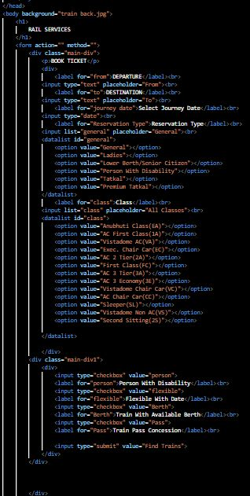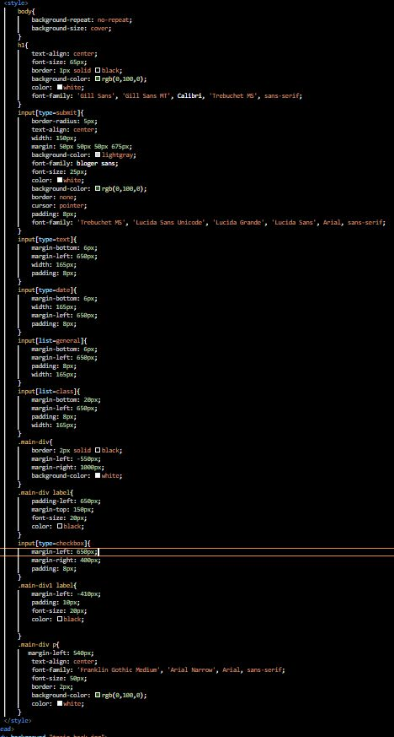

TRAIN TICKET CANCELLATION

HTML SOURCE:

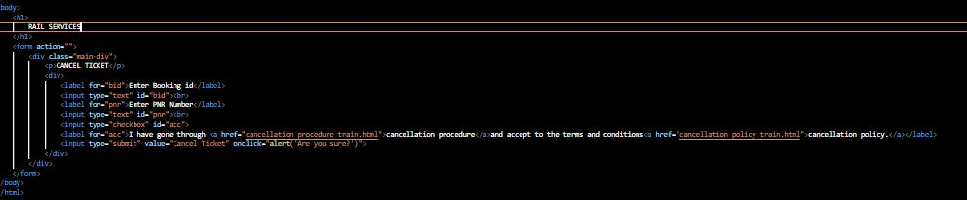

CSS SOURCE:

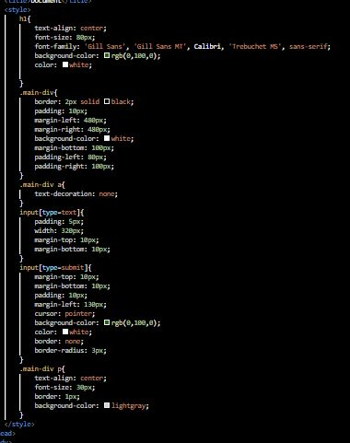

FLIGHT BOOKING

HTML SOURCE:

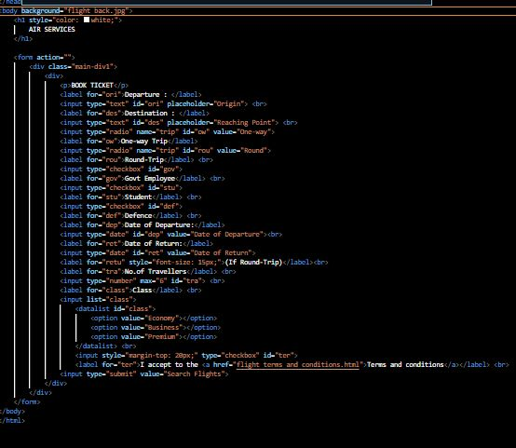

CSS SOURCE:

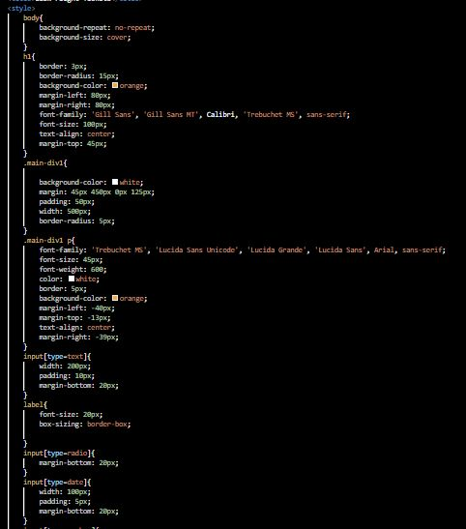 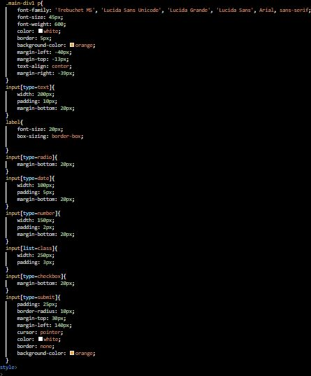

FLIGHT TICKET CANCELLATION

HTML SOURCE:

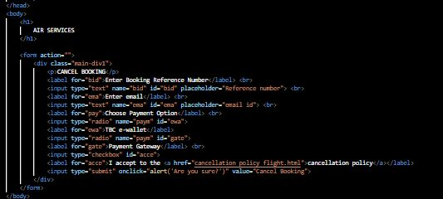

CSS SOURCE:

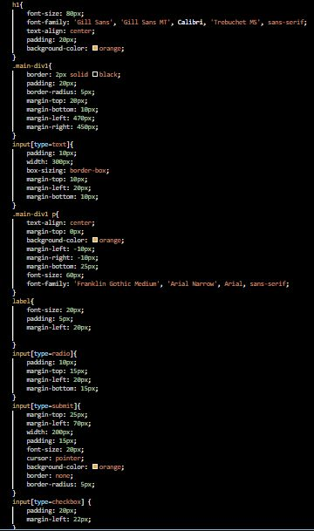

HOTEL BOOKING

HTML SOURCE:

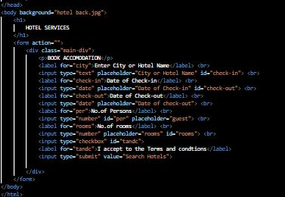

CSS SOURCE:

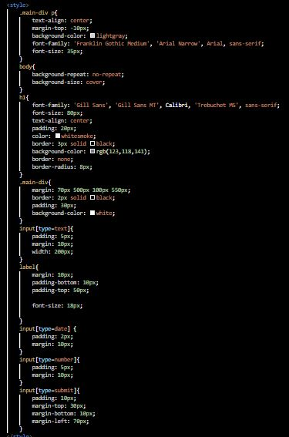

MEAL BOOKING DURING TRAIN JOURNEY

HTML SOURCE:

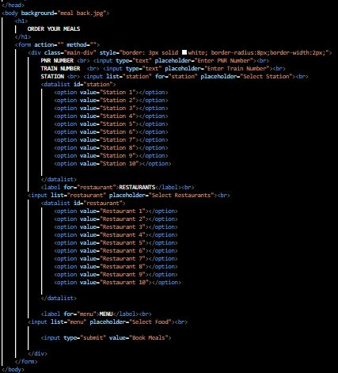

CSS SOURCE:

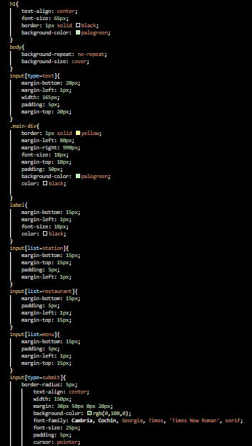

LOGIN PORTAL

HTML SOURCE:

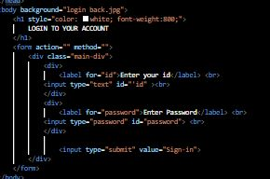

CSS SOURCE:

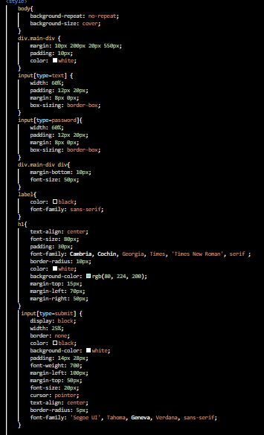

REGISTRATION PORTAL

HTML SOURCE:

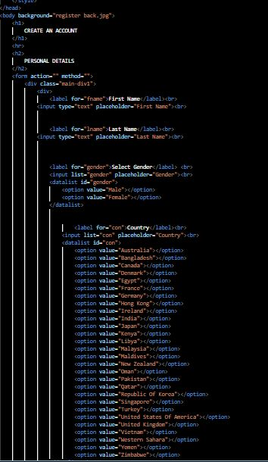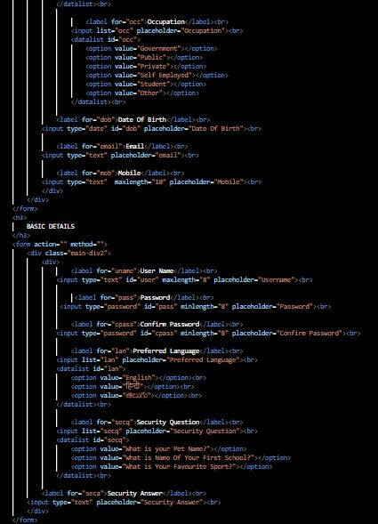

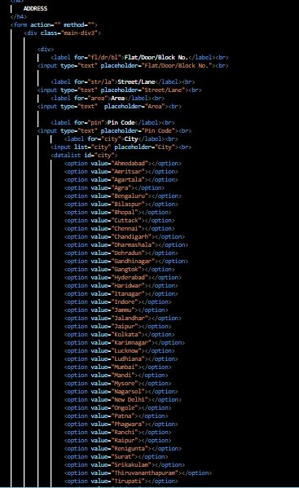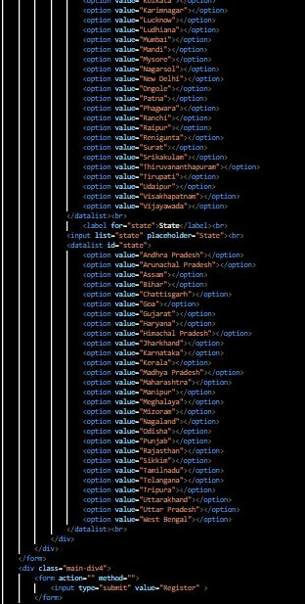

CSS SOURCE:

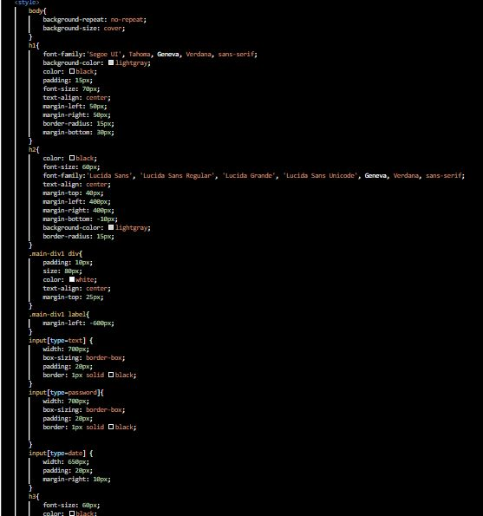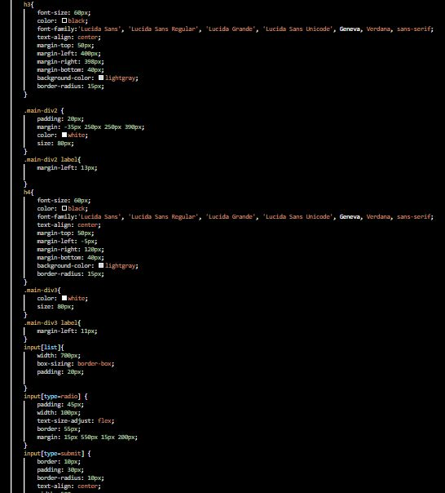

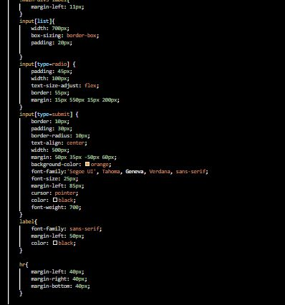

RESULT

HOME PAGE

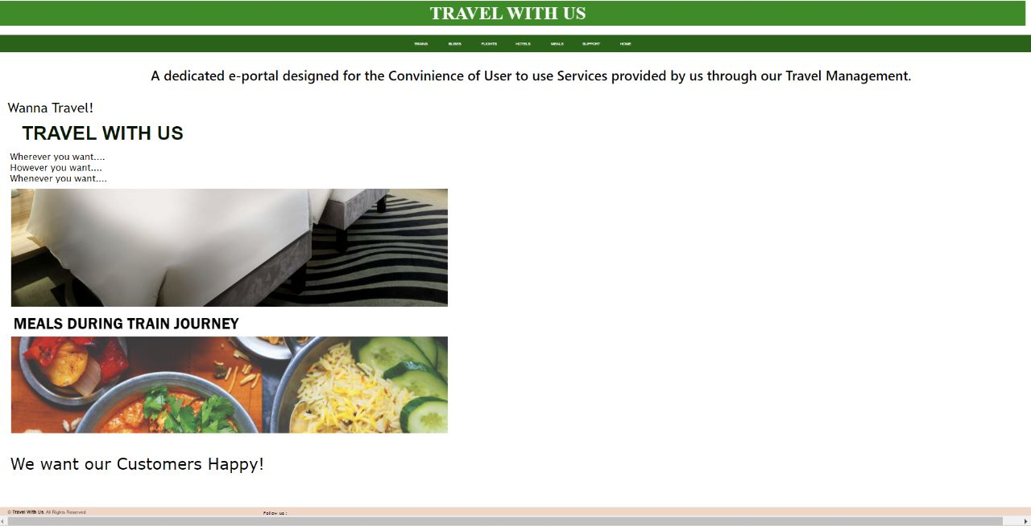

BUS BOOKING

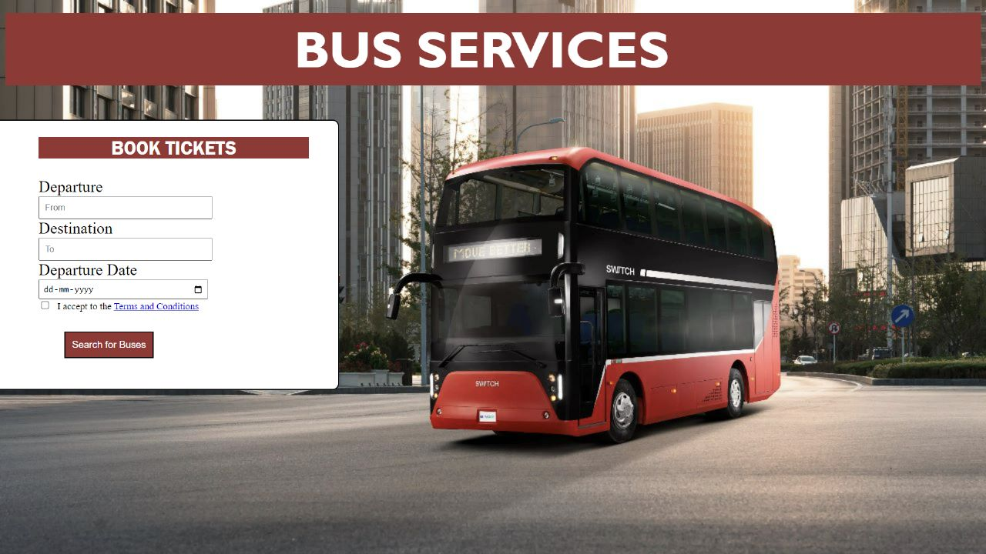

TRAIN BOOKING

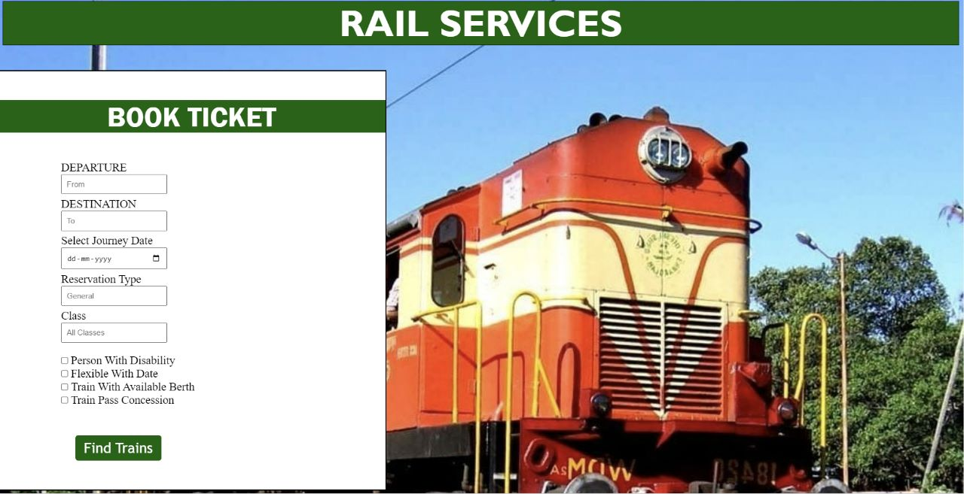

FLIGHT BOOKING

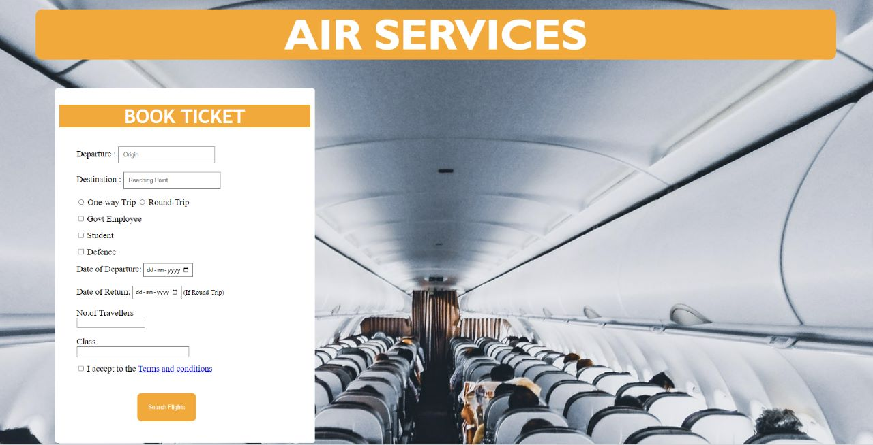

FLIGHT TICKET CANCELLATION

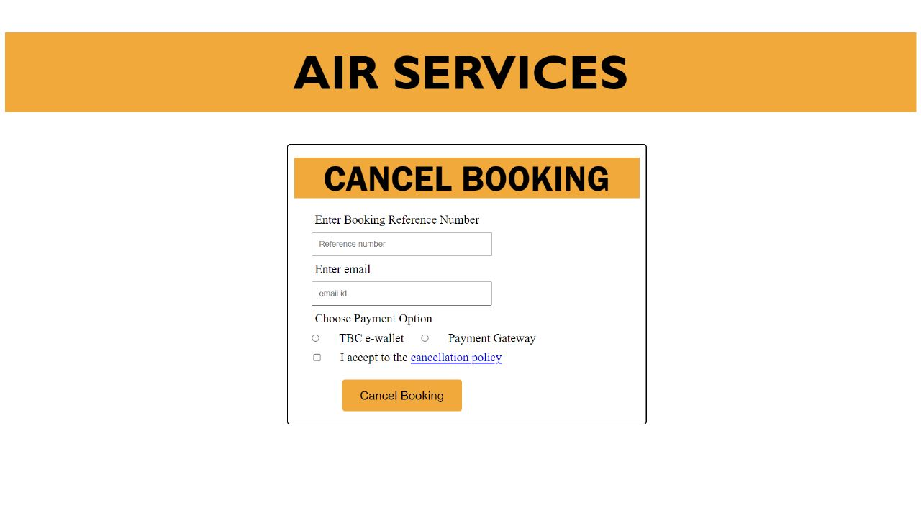

BUS TICKET CANCELLATION

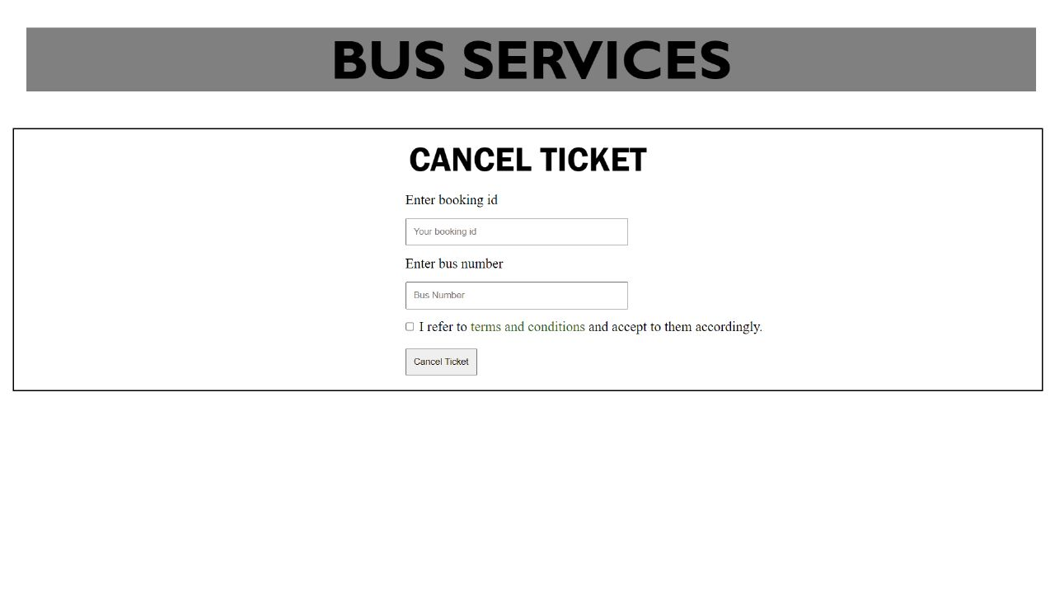

TRAIN TICKET CANCELLATION

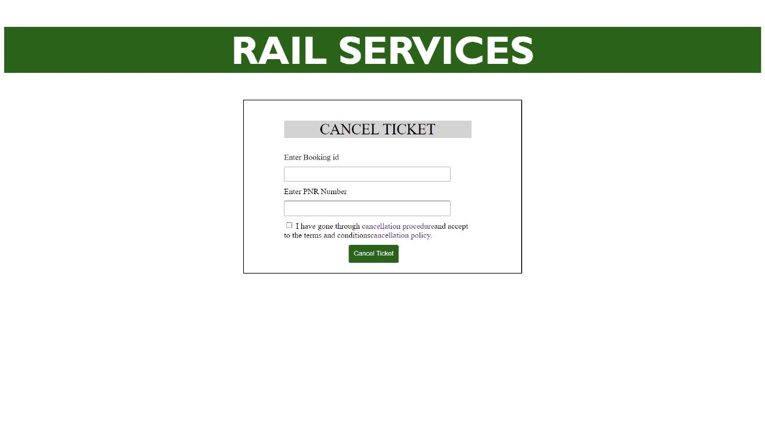

HOTEL BOOKING

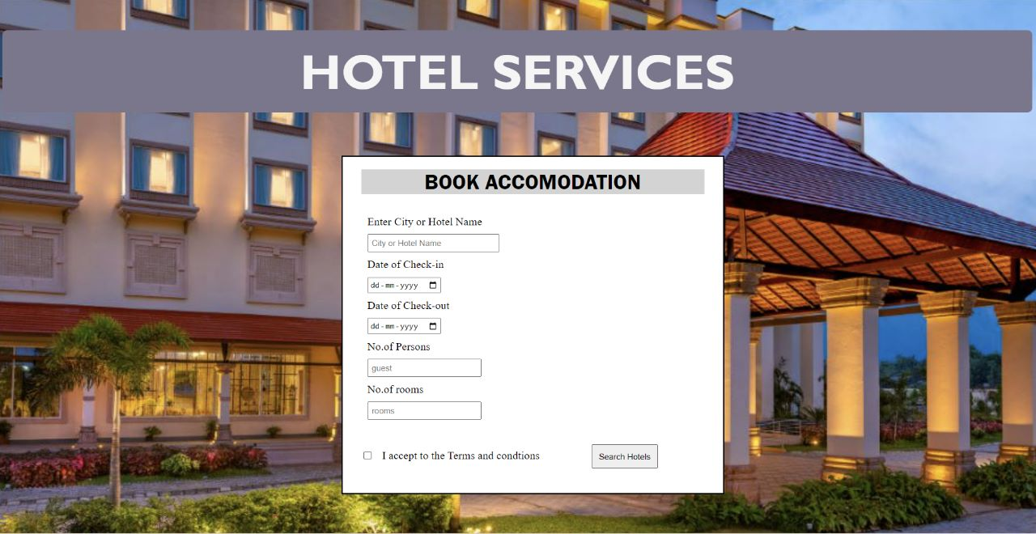

MEALS BOOKING DURING TRAIN JOURNEY

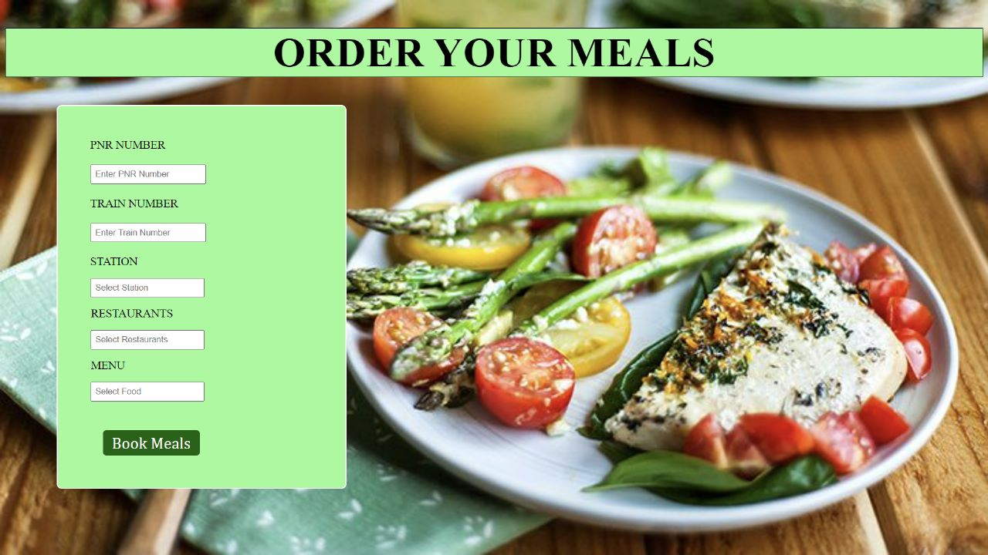

LOGIN PORTAL

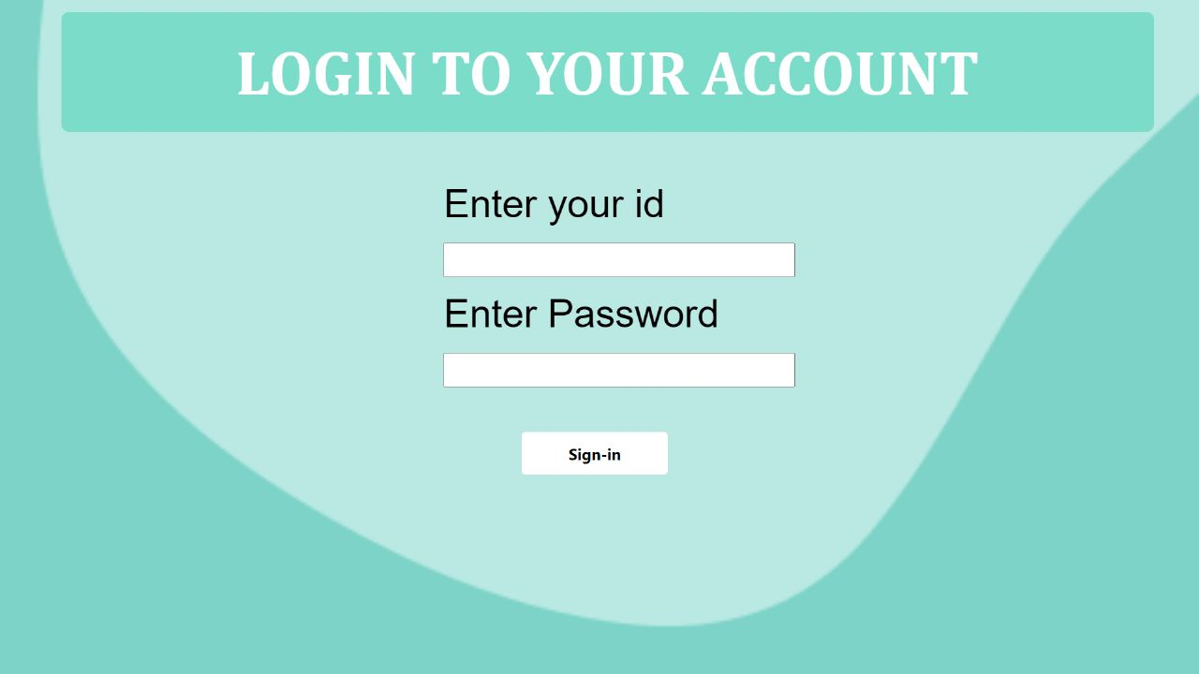

REGISTRATION PORTAL

